**FURKAN GÜL**

Computer

Engineer

**CONTACT ME AT :**

**Phone:**

+90-507-5847722

**E-mail:**

furkan1287@gmail.com

**Adress:**

Soğuksu Mahallesi Yönetmen Sokak No:17/2 İstanbul/Beykoz

**ABILITIES**

Logical thinking and problem

solving

Coding

Conflict resolution

**REFERENCES**

**Reference will be provided in case of need.**

**PROFILE**

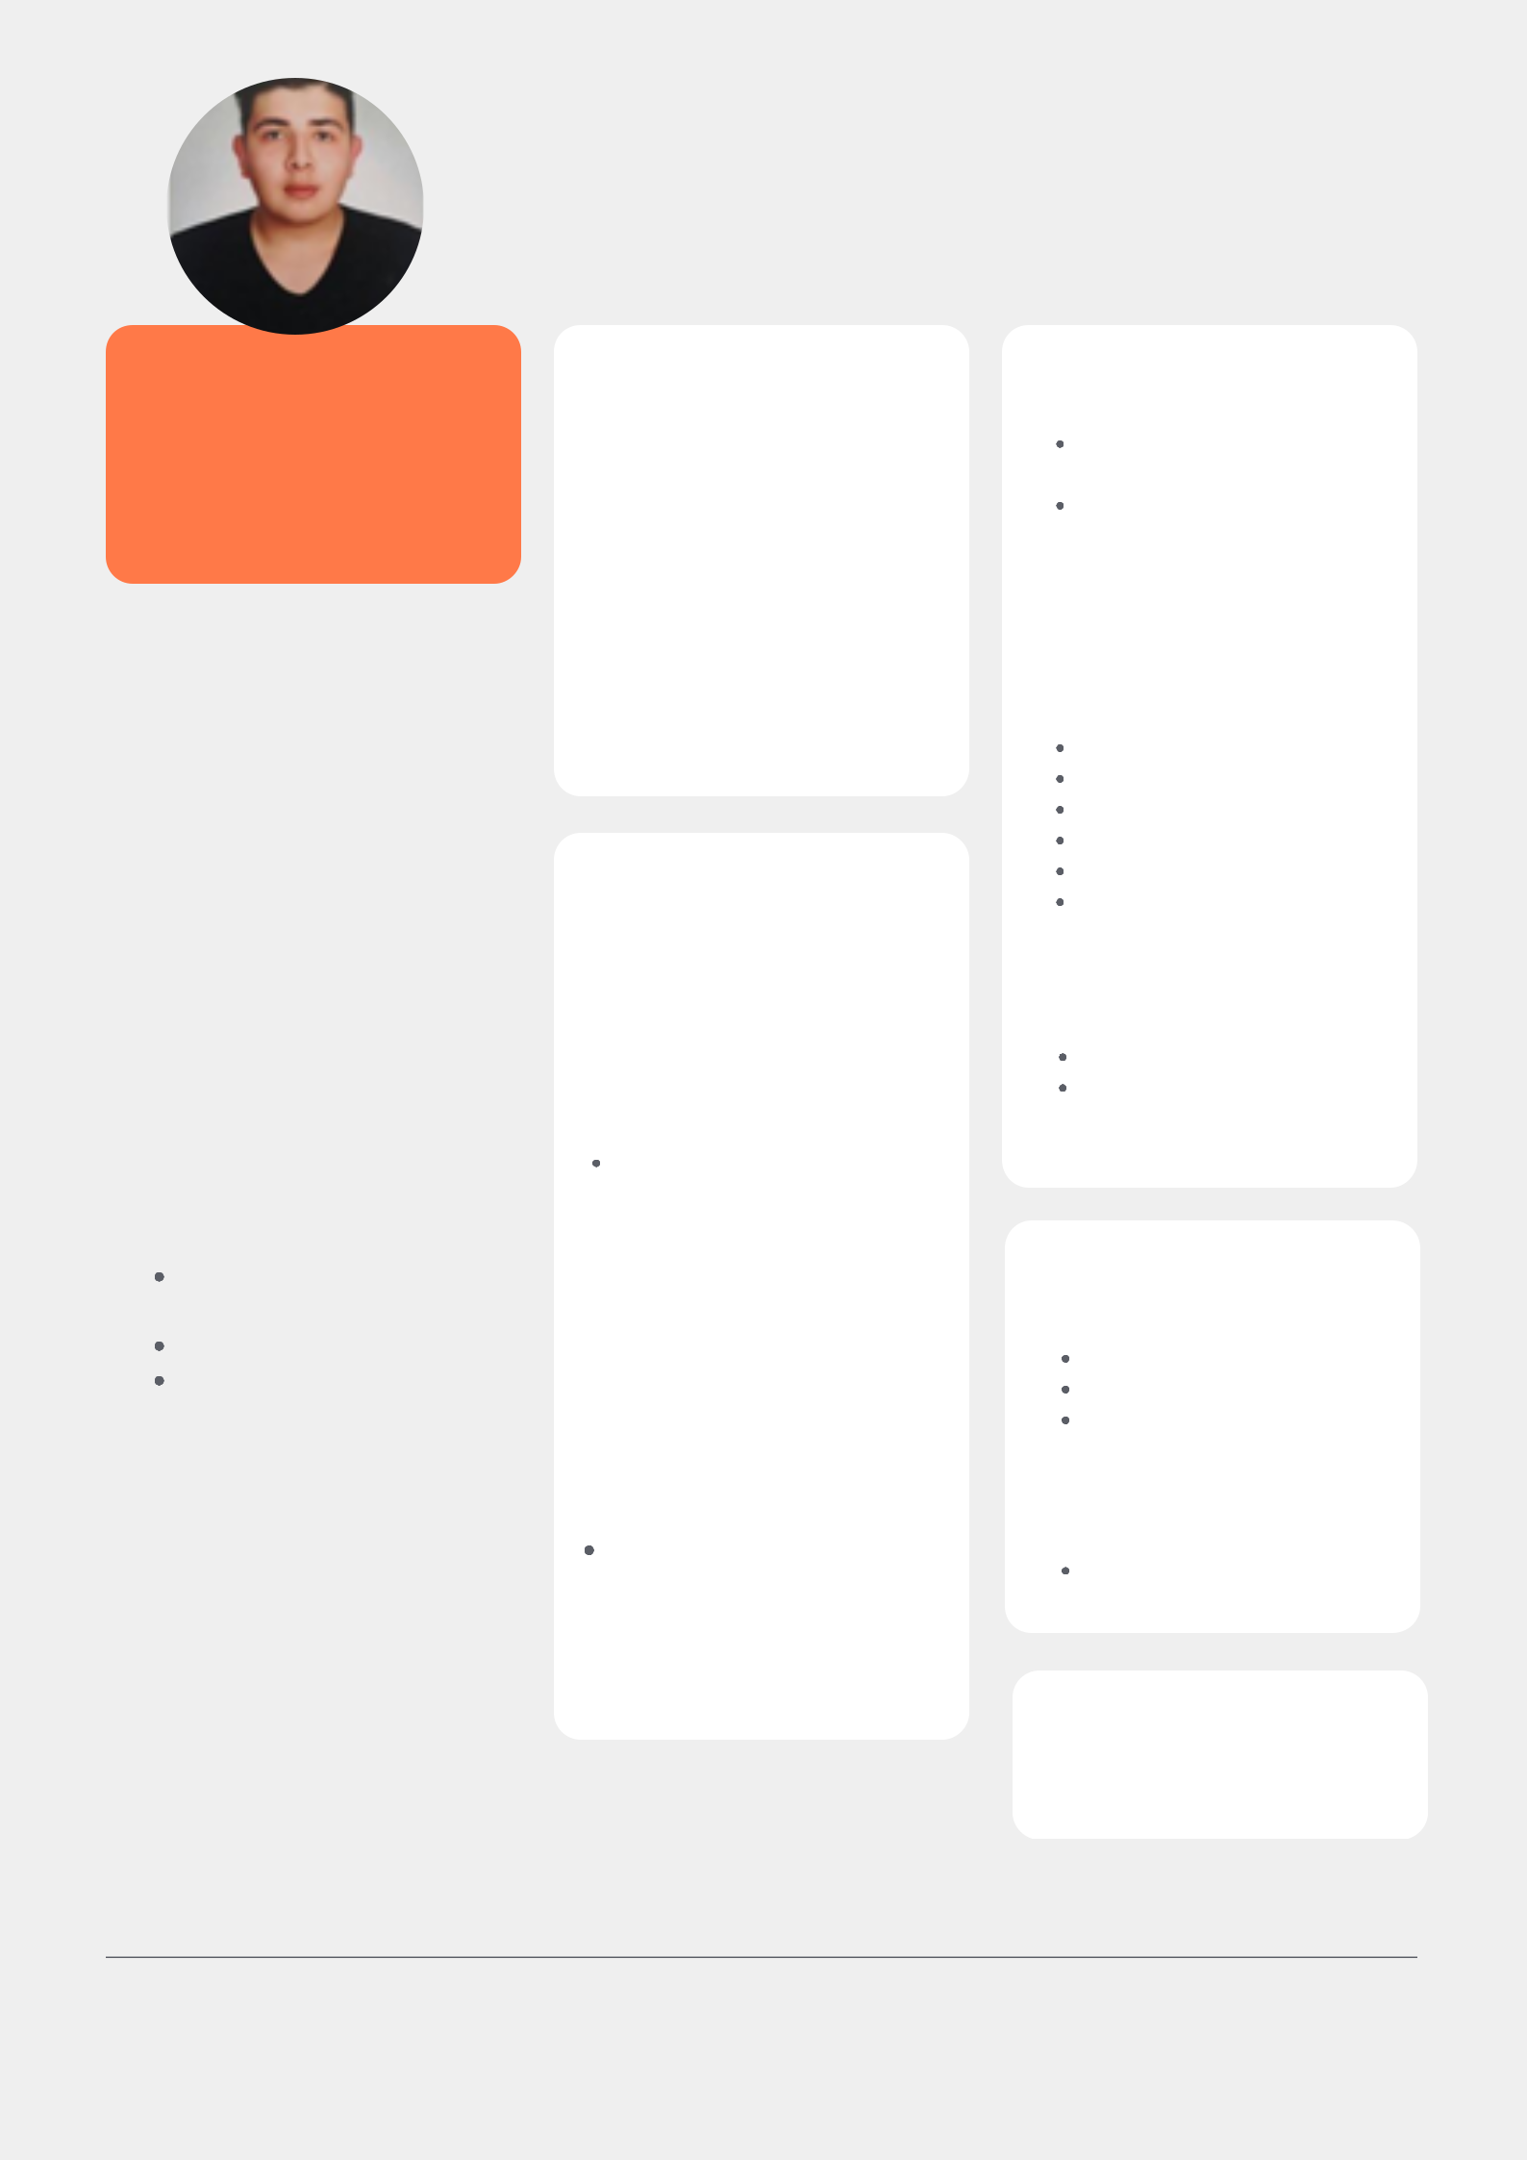

I'm a strong team player who is able to quickly learn and apply new technologies.

**EDUCATION**

**Adana Alparslan Türkeş**

**Science and Technology**

**University**

Faculty of Engineering/Computer Engineering

I have been studying computer engineering since 2017 and improving myself field of data science and cyber security.

**SEMINARS & TRAININGS**

01.2019 İŞKUR

Future Professions

Trainings (Robotics

coding) (180 hours)

**EXPERIENCE**

FMSS-06.2022-9.2022 Java Backend Intern

07.2020-10.2020 Prep cook New Shoreham, RI ABD (Work and Travel Program)

**SKILLS / COMPETENCIES**

**Software Languages**

Python

Java

JS

Html

Css

Sql

**LANGUAGES**

Turkish (Native)

English (B2)

**OPERATING**

**SYSTEMS/TECHNOLOGIES**

Windows

Linux

Ms office

**VOLUNTEER EXPERIENCE**

02.2021-01.2022

AIESEC

**INTERESTS**

Fitness

Boxing

Literature